Advanced WindowsCare

Go to http://hnkstr.com/PC%20Utilities/Advanced%20Window%20Care/AWCSetup.exe

When this warning comes up click Run

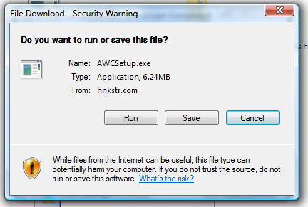

The setup file will now download



When the file is done downloading, click Run to start the setup

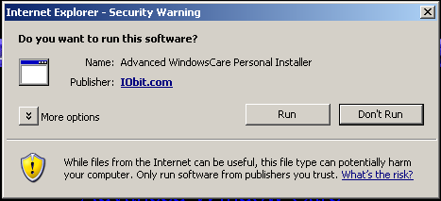

Click Next

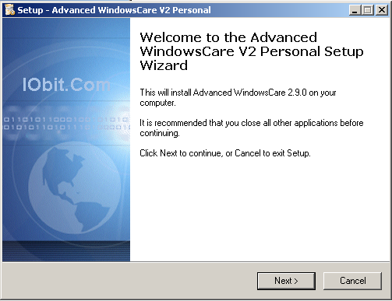

Click I accept the agreement radio button and click Next

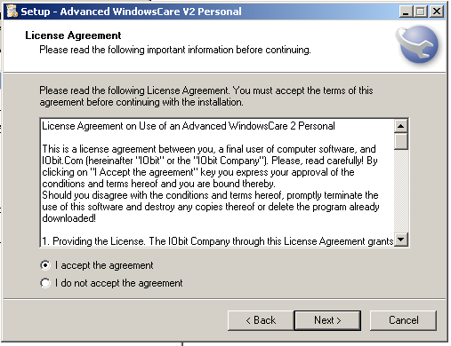

Click Next at the Information window

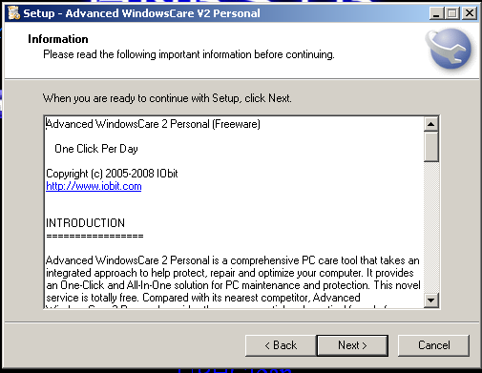

Leave the Destination Location and click Next

\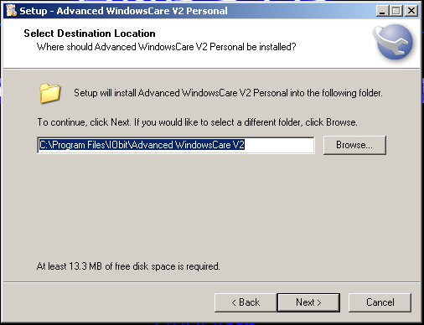

Leave the Start menu Folder and click Next

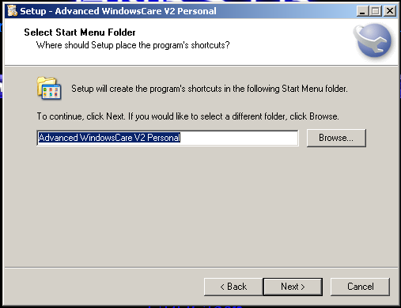

Leave all the check boxes checked and click Next

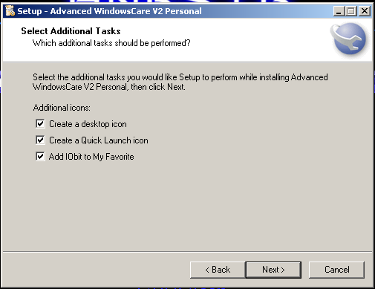

At this Window, Uncheck the I Agree to Install the Yahoo! Toolbar and the Make Yahoo! My default search Engine
Click Next

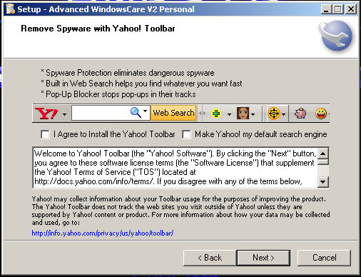

Click the Install button

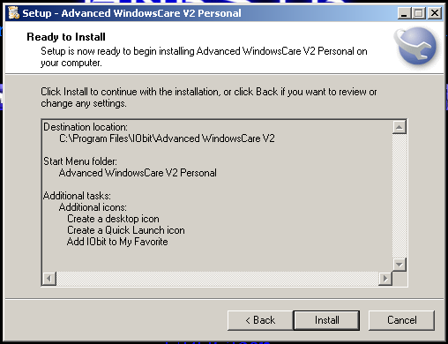

It will then start to install and you will see a progress bar

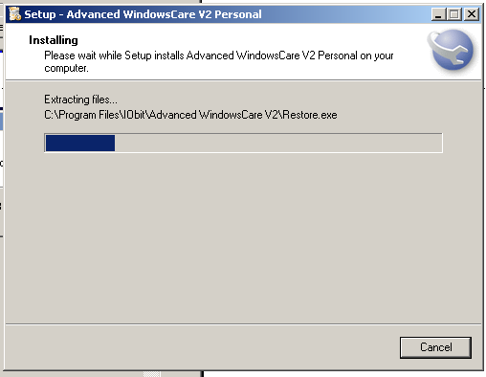

Click Next

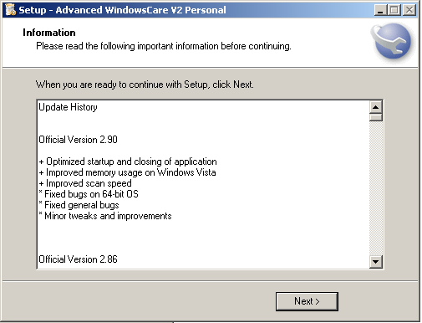

After the program is done installing, click the Finish button

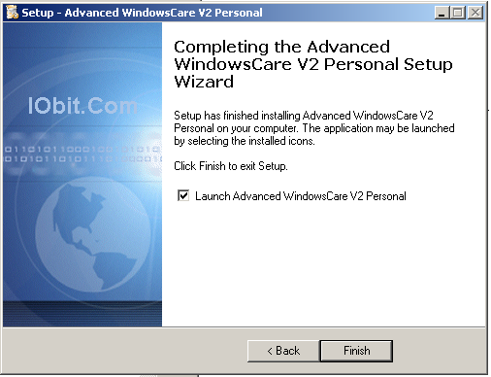

Leave English as the Program Language and click OK

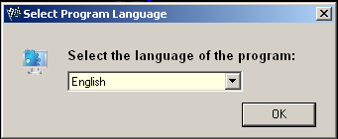

The Program will now start and Initialize

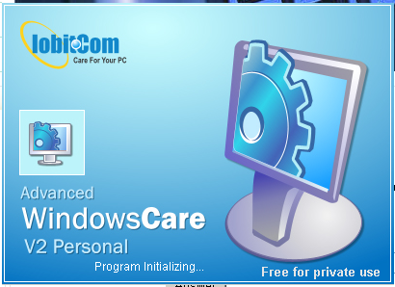

Click No for the System Backup

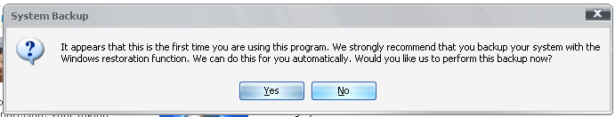

Advanced WindowsCare now starts.
Click the Scan button at the bottom to start

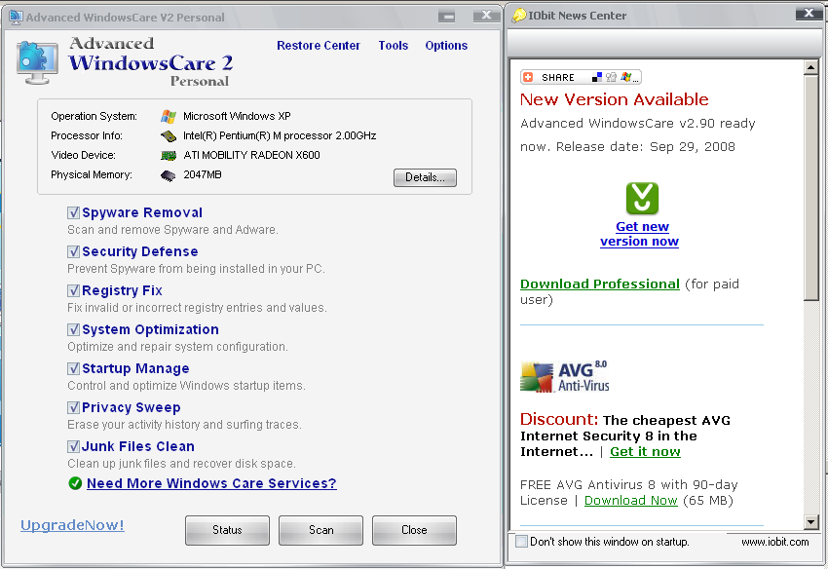

You will see Red Arrows next to stage the program is in

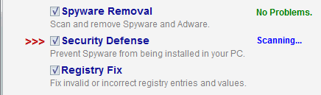

When it is done scanning, it will tell you the results
Now click the Repair button

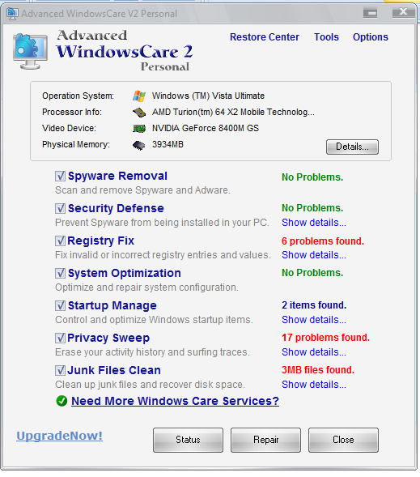

After it is done Repairing, just click Later as you don’t need to see the Reports

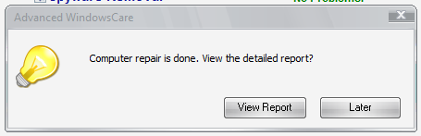

Click Close

